**EE092IU**

**DIGITAL SIGNAL PROCESSING LABORATORY**

**Lab 4**

Z TRANSFORM

# Full name: Nguyen Gia Cat Tuong

**Student number: ITITIU21117**

**Class: DSP Lab Tuesday afternoon**

**Date: April 11th, 2023**

1. **OBJECTIVES**

Students know how to write m-file in Matlab to illustrate the properties of Z transform.

# REQUIRED EQUIPMENT

* 1. Computer
  2. Matlab software

# INTRODUCTION

Just as with the Laplace transform for continuous-time signals and systems, the Z-transform provides a way to represent discrete-time signals and systems, and to process discrete-time signals. Although the Z-transform can be related to the Laplace transform, the relation is operationally not very useful. However, it can be used to show that the complex z-plane is in a polar form where the radius is a damping factor and the angle corresponds to the discrete frequency w in radians. Thus, the unit circle in the z-plane is analogous to the jw axis in the Laplace plane, and the inside of the unit circle is analogous to the left-hand s-plane. We will see that once the connection between the Laplace plane and the z-plane is established, the signiﬁcance of poles and zeros in the z-plane can be obtained like in the Laplace plane.

The representation of discrete-time signals by the Z-transform is very intuitive—it converts a sequence of samples into a polynomial. The inverse Z-transform can be achieved by many more methods than the inverse Laplace transform, but the partial fraction expansion is still the most commonly used method. Using the one-sided Z-transform, for solving difference equations that could result from the discretization of differential equations, but not exclusively, is an important application of the Z-transform.

## Mathematical Definition

The 𝑧 transform of a discrete time signal is defined as:

|  |  |
| --- | --- |
| ∞  𝑋(𝑧) = ∑ 𝑥[𝑛]𝑧−𝑛  𝑛=−∞ | (1) |

**Example 1:** Compute the z-transform of the sequence

*x**n*  3,5, 4,3, 0  *n*  3

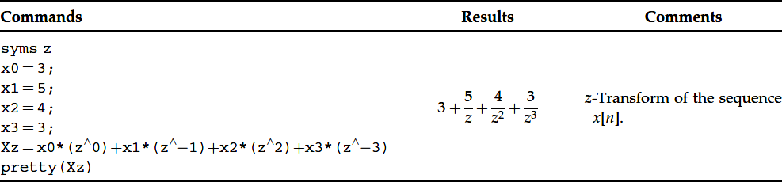

An alternative and more elegant computation of the z-transform

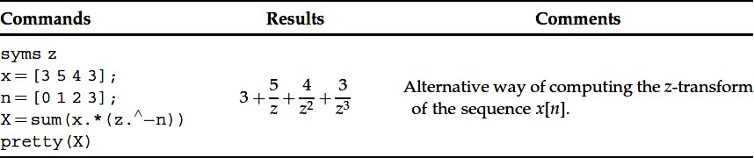

**Example 2:** Compute the z-transform of the sequence

*x* *n*  0.9*nu* *n*

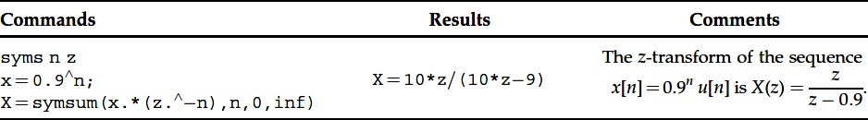

In MATLAB, the z-transform

*F*  *z*

of a sequence

*f* *n*

is computed easily by using the

command *ztrans*. Moreover, the inverse z-transform of a function the command *iztrans*.

*F*  *z* is computed by using

Before using these two commands, the declaration of the complex variable z and of the discrete time n as symbolic variables is necessary. Recall that in order to deﬁne a symbolic variable, the command syms is used.

**Example 3:** Compute the z-transform of the sequence

*f* *n*  2*n*

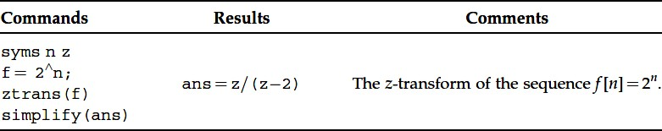

**Example 4:** Compute the inverse z-transform of the function

*z*

*F*  *z*  

 *z*  2

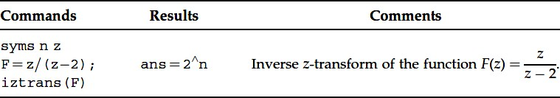

**Example 5:** Using Partial Fraction Expansion of a Rational Function, express in the partial fraction form the signal which in the z-domain is given by

*z*2  3*z* 1

 

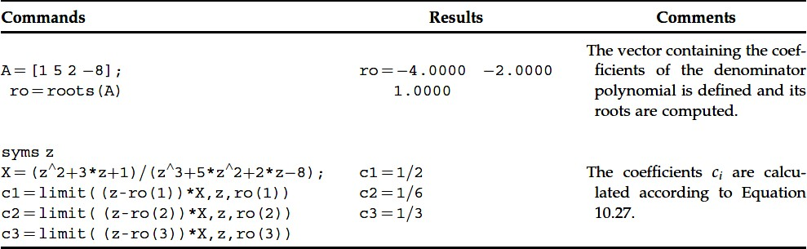*X z*  *z*3  5*z*2  2*z*  8

**Example 6:** Using Partial Fraction Expansion of a Rational Function, express in the partial fraction form the signal which in the z-domain is given by

*z*2  3*z* 1

 

*X z*  *z*3  3*z*  2

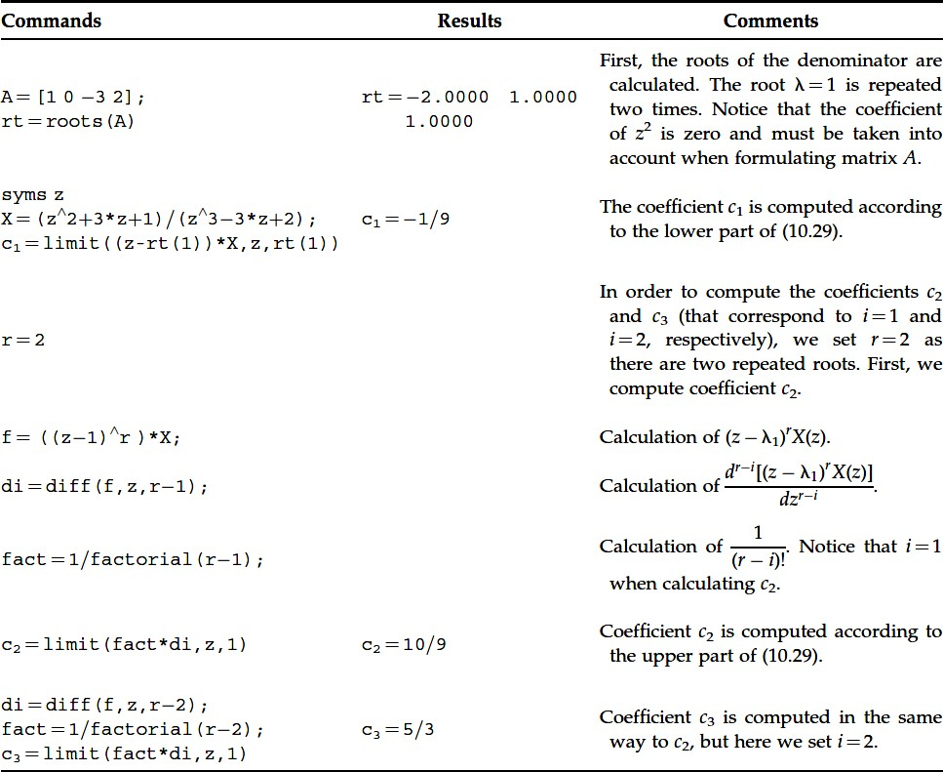

We also can use *residue* command

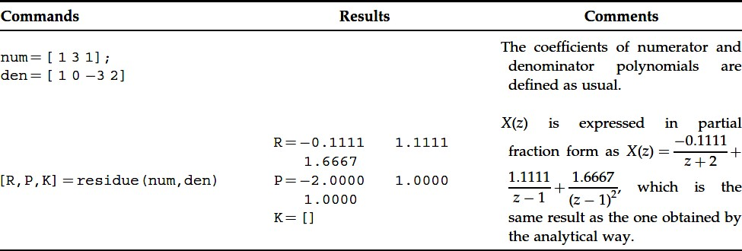

## Basic Properties of the Z Transform

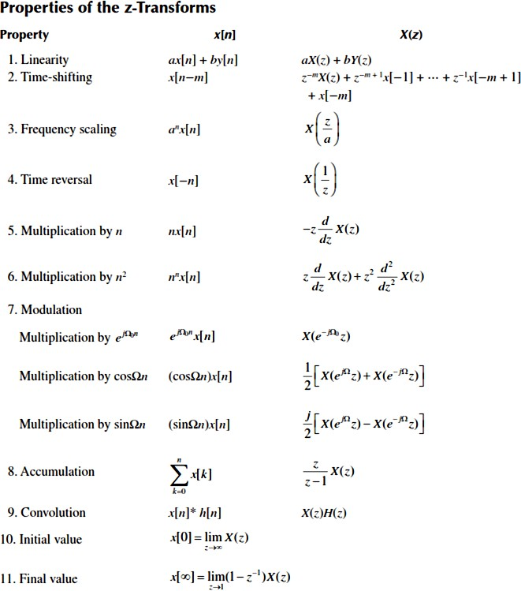

Table 1: Z-transform property

## Z Transform Pairs

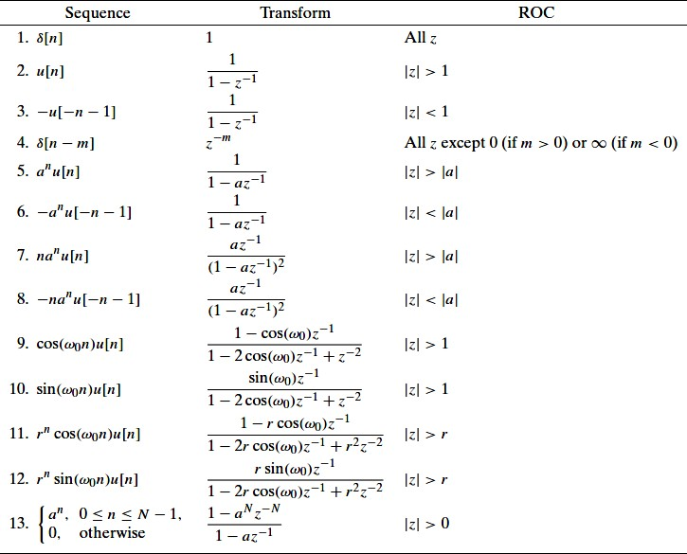

Table 2: Z-transform pairs

## 3.4 Using the z-Transform to Solve Difference Equations

**Example 7:** Find the solutions of the difference equation y[n] +0.5y[n-1] + 2y[n-2] = 0.9n u[n], where y[n] = 0, n < 0

## Solution:

We have:

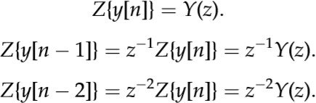

The computational procedure as follow:

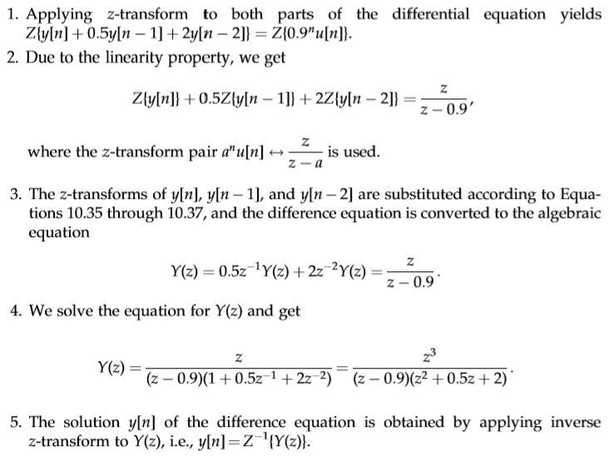

# In Matlab:

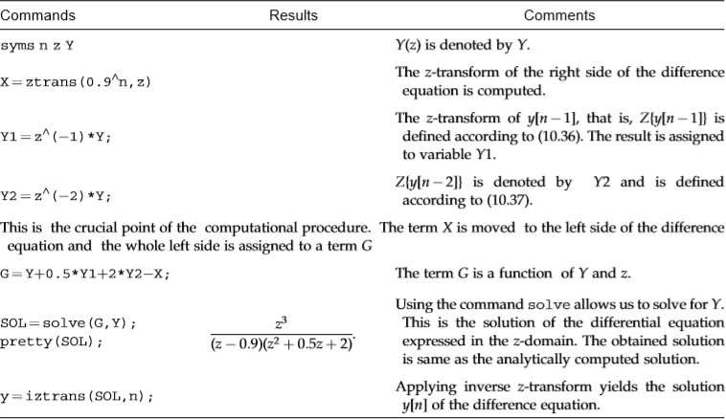

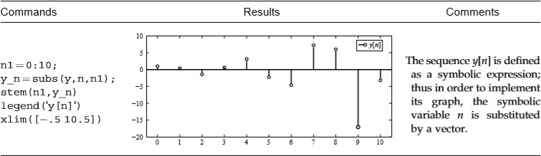

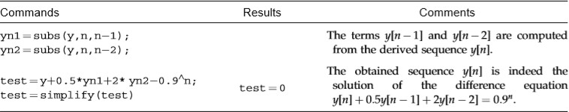In order to confirm that y[n] is in fact the solution of the difference equation, y[n] is inserted to the difference equation, if it satisfies the difference equation, then it is indeed its solution

# PROCEDURE

## Problem 1:

Express in partial fraction form the signal and determine

*x* *n*

*X*  *z*  

12  38*z*1 11*z*2  3*z*3  54*z*4

1 5*z*1  6*z*2

2*z*2  *z* 1

*X*  *z*  

*z*3  3*z*  2

*X*  *z*  

5 11*z*1

1 2

## Problem 2:

1 5*z*  6*z*

Compute of the Z-transform of the following sequence using the symbolic toolbox of MATLAB

ℎ1[𝑛] = 0.8𝑢(𝑛)

ℎ2[𝑛] = 𝑢[𝑛] − 𝑢[𝑛 − 10] ℎ3[𝑛] = 𝑐𝑜𝑠(𝜔0𝑛)𝑢[𝑛]

ℎ4[𝑛] = ℎ1[𝑛]ℎ3[𝑛]

clc

clear all

pkg load symbolic

syms n z w

x=0.8;

h_1 = symsum(x.*(z.^-n),n,0,inf)

h_2 = symsum((z.^-n)-(z^(-n-10)),n,0,inf)

h_3 = symsum(cos(w*n)*(z.^-n),n,0,inf)

h_4 = symsum(x.*cos(w*n),n,0,inf)

disp('Sequence 1')

ztrans(h_1)

disp('Sequence 2')

ztrans(h_2)

disp('Sequence 3')

ztrans(h_3)

disp('Sequence 4')

ztrans(h_4)

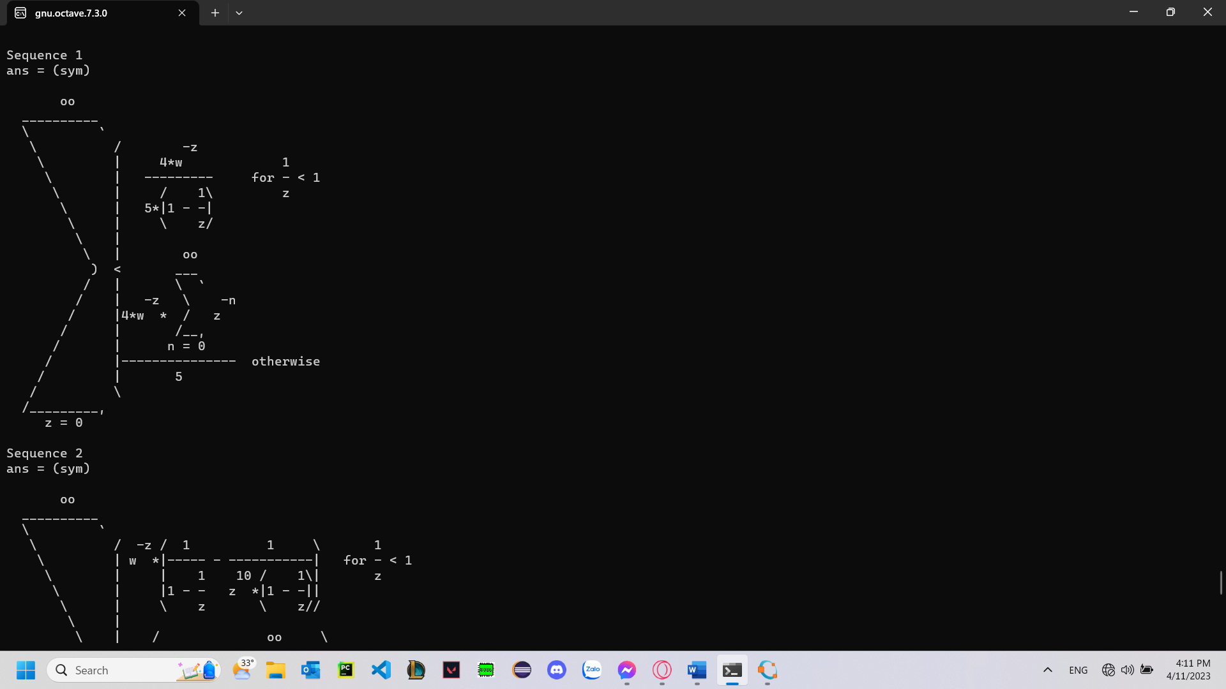

## Problem 3:

Consider an FIR filter with impulse response

*h**n*  ** *n* ** *n* 1  ** *n*  2

Find the filter output for an input

*x* *n*  cos 2* n* 3 *u* *n*  *u* *n* 14

Use the convolution sum to find the output, and verify your results with MATLAB. Use z-transform to find the output

We have: y(n) = x(n)*h(n) =

By convolution with impulse property

x(n)*

Therefore, y(n) = x(n)*[]

y(n) = x(n) + x(n – 1) + x(n – 2)

x(n) = cos(

Therefore, y(n) = cos(

**Code:**

n1 = 0:1:13;

x1 = cos(2*(pi/3)*n1);

stem(n1, x1)

subplot(2,2,1)

n2 = 1:1:14;

x2 = cos(2*(pi/3)*(n2-1));

stem(n2, x2)

subplot(2,2,2)

n3 = 2:1:15;

x3 = cos(2*(pi/3)*(n3-2));

stem(n3, x3)

subplot(2,2,3)

n4 = n1:1:n3;

y = cos(2*(pi/3)*n1)+cos(2*(pi/3)*n1)+cos(2*(pi/3)*(n2-1))+cos(2*(pi/3)*(n3-2));

stem(n1, y)

subplot(2,2,4)

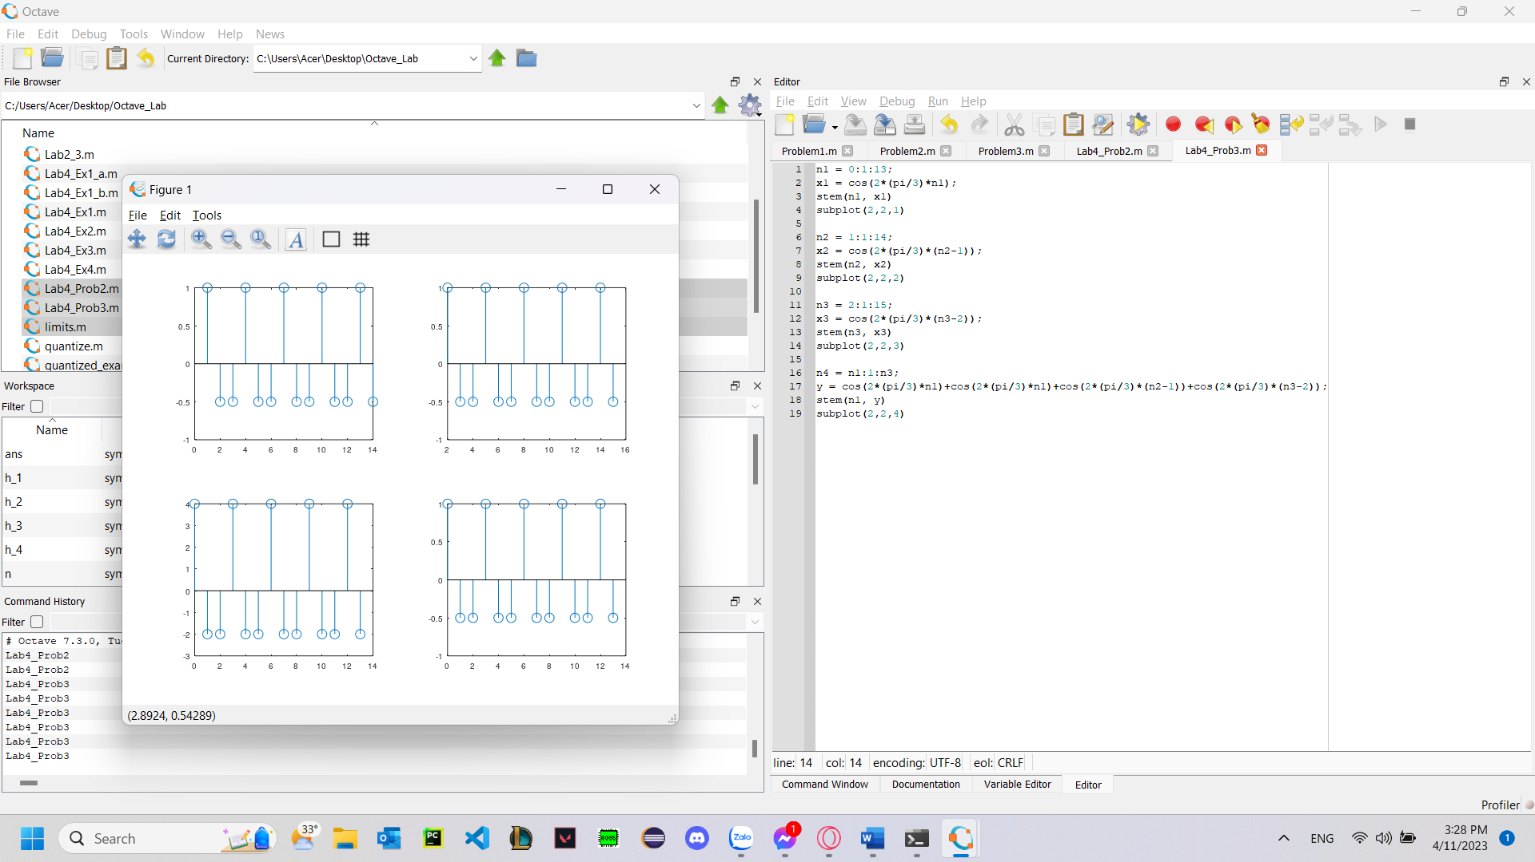

## Problem 4:

Use z-transform to ﬁnd the solution of the difference equations:

a/ y[n] + 1.5 y[n-1] + 0.5y[n-2] = x[n] + x[n-1], where x[n] = 0.8n u[n]

b/ y[n] – y[n-1] = x[n] + x[n-1], where x[n] = 0.8n u[n]

Plot the solution for 0 < n < 20.

Conﬁrm your result by inserting the obtained solution in the difference equation.

a/ There is no initial condition, we take z-transform on both sides:

Y(z) + 1.5*z-1Y(z) + 0.5*z-2Y(z) = X(z) + z-1X(z)

Y(z)*(1 + 1.5*z-1 + 0.5*z-2) = X(z)*(1+z-1)

(1)

We have: x(n) = 0.8nu[n]

* X(z) =

From equation (1), we have:

Y(z) =

Using partial fraction:

Therefore,

.5)nu[n] - .8)nu[n] + 20u[n]

.5)n - .8)n + 20]*u[n]

**Code:**

n=0:20;

yn = ((5*(0.5).^n)-(24*(0.8).^n)+(20))

stem(n, yn)

grid on

xlabel("Samples (n)")

ylabel("Magnitude")

b/ There is no initial condition, we take z-transform on both sides:

Y(z) + z-1Y(z) = X(z) + z-1X(z)

Y(z)*(1 + z-1) = X(z)*(1 + z-1)

(1)

We have: x(n) = 0.8nu[n]

* X(z) =

From equation (1), we have:

Y(z) =

0.8nu[n]

**Code:**

n=0:20;

yn = (0.8).^n

stem(n, yn)

grid on

xlabel("Samples (n)")

ylabel("Magnitude")

